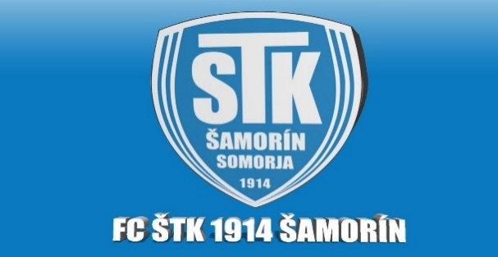

***SKUPINA A KATEGÓRIA U10***

|  |  |  |  |  |  |  |  |  |
| --- | --- | --- | --- | --- | --- | --- | --- | --- |
| **ŠAMORÍN CUP 2022** | ***FC ŠTK 1914 Šamorín*** | ***SFA*** | ***SDM Domino*** | ***Inter BA žltý*** | ***MFK Skalica zelený*** | **Skóre** | **Body** | **Poradie** |
| ***FC ŠTK 1914 Šamorín*** | **ŠAMORÍN CUP 2022** |  |  |  |  |  |  |  |
| ***SFA*** |  | **ŠAMORÍN CUP 2022** |  |  |  |  |  |  |
| ***SDM Domino*** |  |  | **ŠAMORÍN CUP 2022** |  |  |  |  |  |
| ***Inter BA žltý*** |  |  |  | **ŠAMORÍN CUP 2022** |  |  |  |  |
| ***MFK Skalica zelený*** |  |  |  |  | **ŠAMORÍN CUP 2022** |  |  |  |

***SKUPINA B KATEGÓRIA U10***

|  |  |  |  |  |  |  |  |  |
| --- | --- | --- | --- | --- | --- | --- | --- | --- |
| **ŠAMORÍN CUP 2022** | ***DAC Dunajská Streda*** | ***Spartak Trnava*** | ***KFC Komárno*** | ***Inter BA čierny*** | ***MFK Skalica biely*** | **Skóre** | **Body** | **Poradie** |
| ***DAC Dunajská Streda*** | **ŠAMORÍN CUP 2022** |  |  |  |  |  |  |  |
| ***Spartak Trnava*** |  | **ŠAMORÍN CUP 2022** |  |  |  |  |  |  |
| ***KFC Komárno*** |  |  | **ŠAMORÍN CUP 2022** |  |  |  |  |  |
| ***Inter BA čierny*** |  |  |  | **ŠAMORÍN CUP 2022** |  |  |  |  |
| ***MFK Skalica biely*** |  |  |  |  | **ŠAMORÍN CUP 2022** |  |  |  |